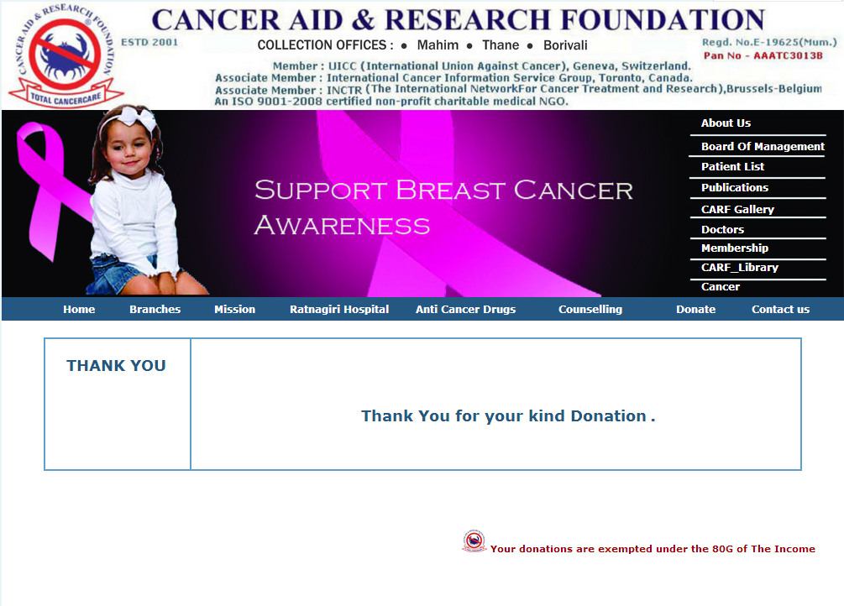

**Mail from CCAvenue**

From: <[no-reply@ccavenue.com](mailto:no-reply@ccavenue.com)>  
Date: Mon, Oct 28, 2013 at 10:56 AM  
Subject: Order No.31509 from CCAvenue  
To: [anand.mail@gmail.com](mailto:anand.mail@gmail.com)

|  |  |  |  |  |  |  |  |  |  |  |  |  |  |  |  |
| --- | --- | --- | --- | --- | --- | --- | --- | --- | --- | --- | --- | --- | --- | --- | --- |
| |  | | --- | | Dear Customer,  Thank you for your order from <http://www.cancerarfoundation.org>  For your convenience, we have included a copy of your order below. **Please Note :-** The charge will appear on your credit card / Account statement as '**Cancer Aid & Research Foundation**'  If you have a question about your order status, you can contact the seller directly by  e-mail at : [cancerarfoundation@yahoo.com](mailto:cancerarfoundation@yahoo.com). |   **ORDER DETAILS:**   |  |  |  |  |  |  |  |  |  |  |  |  |  |  | | --- | --- | --- | --- | --- | --- | --- | --- | --- | --- | --- | --- | --- | --- | | |  |  |  |  |  |  |  |  |  |  |  |  |  | | --- | --- | --- | --- | --- | --- | --- | --- | --- | --- | --- | --- | --- | | |  |  |  |  |  |  |  |  |  |  |  |  | | --- | --- | --- | --- | --- | --- | --- | --- | --- | --- | --- | --- | | |  |  | | --- | --- | | **Merchant Site URL :** <http://www.cancerarfoundation.org> | | | **Order Number: 31509** | Order Received: Oct 28, 2013 |  |  | | --- | |  | | **Total Amount :** INR (Indian Rupees) 2000.00 |  |  |  |  |  |  | | --- | --- | --- | --- | --- | | |  |  |  |  | | --- | --- | --- | --- | | |  | | --- | | **Visa Account Holder :** Anand Nidamanuru | | **Billing Address :** (As entered by the Customer) #20/A, 19th main, BTM 1st stage, Bangalore - 5600029 Bangalore Karnataka 560029 India | | **Customer's Phone Number :** [9886470064](tel:9886470064) **Customer's E-mail ID :** [anand.mail@gmail.com](mailto:anand.mail@gmail.com) **Customer's IP Address :** 106.207.10.134  **Recipient's Name :**  N/A  **Shipping Address :**  N/A N/A N/A N/A N/A  **Recipient's Phone Number :**  N/A  **Special Instructions :** Donation for Master Shree Rupesh | | | | | | |